

Site Plan

Site Purpose

The main purpose of the page is to help anybody who wants to rent motor scooters, jeeps, and side-by-sides ATVs, the page will have the current weather in the different locations, also a 5 days forecast, It will provide tourist information and activities for every place.

Target Audience

Who: Everyone with a time to relax.

Age: 12 to 100

Technology: No technology knowledge required

Income: Income levels will typically be between $30,000 and above annually.

Personas

John B. Smith

**Occupation:** Businessman

**Demographics and Education:** 30 years old**,** has a master level education, works in a big company.

**Goals and motivation for using the site:** Relax himself from a stressful work, rent a scoot or a jeep for his vacations

**Social:** He enjoys social media.

**Technology:** He spends his day in a computer, making graphs for the company.

**Quote:** “There is time for everything”

David Aston

**Occupation:** Teacher

**Demographics and Education:** 45 years old, Teach history in a primary school.

**Goals and motivation for using the site:** Find a good way to spend his vacations

**Social:** He likes to visit his family in his vacations.

**Technology:** He uses his computer only to create and review the assignments

**Quote:** “The knowledge is for everybody”

Site Map

Home

Contact

Tours

Reservations

Rentals

Color Scheme

<https://coolors.co/e4ff1a-f87060-41ead4-2b59c3-000000-eee5e9>

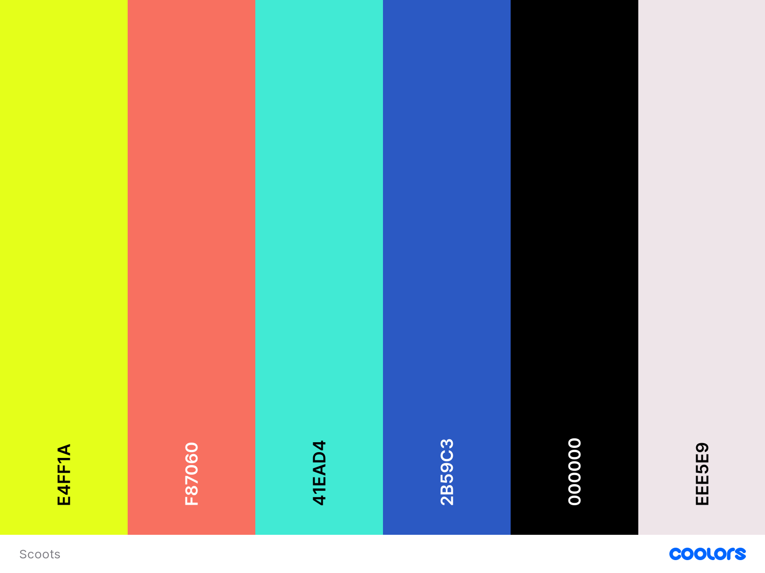

Typography

Headers : Nunito

Example

Paragraphs and text : Noto sans SC

Example

Wireframes

Web:

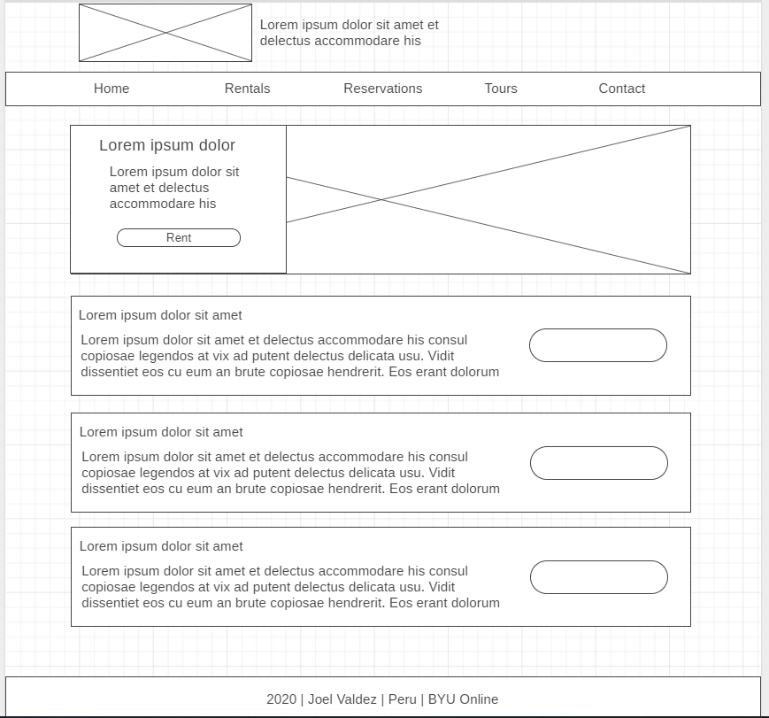

Tablet

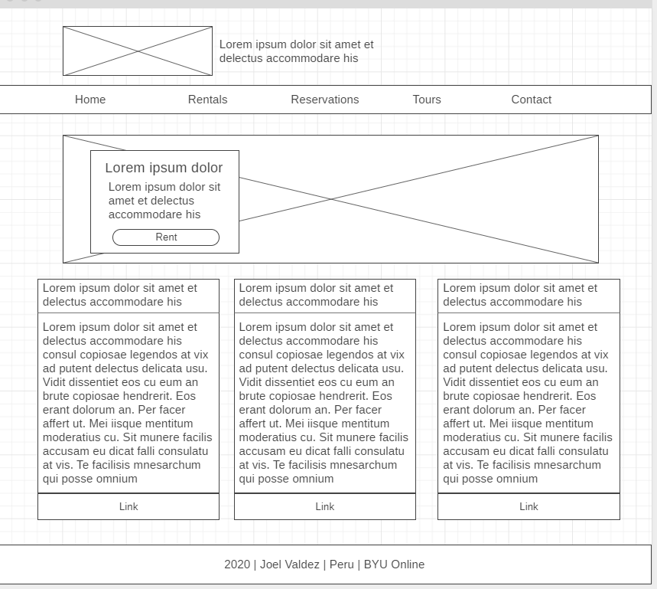

Phone:

